***BLOCK CHAIN SMART CONTRACTS FORMALIZATION***

**DECENTRALIZED LENDING SYSTEM**

Axioms are equally contributed by all.

A decentralized lending system addresses several critical use cases and problems in the traditional financial industry. Firstly, it enables individuals and entities to access capital without relying on banks and traditional financial institutions, making it particularly valuable for those in underserved regions or lacking access to traditional banking. Furthermore, it offers a solution to the problem of trust and transparency by using blockchain technology to create tamper-proof lending agreements and transaction records, mitigating the risk of fraud and disputes. Additionally, decentralized lending allows users to earn interest on their crypto assets by lending them out, and it provides borrowers with a way to secure loans without complex credit checks, making it more inclusive and accessible. Finally, it reduces the reliance on costly intermediaries, streamlining the lending process and reducing fees, which is advantageous for both lenders and borrowers.

**If statement**

C code

#include <stdio.h>

int approveLoan(int *request) {

int approval = 0;

if (*request > 0) {

if (*request <= 1000) {

approval = 1;

} else {

approval = 0;

}

} else {

approval = 0;

}

return approval;

}

int main() {

int loanRequest;

printf("Enter the loan request amount: ");

scanf("%d", &loanRequest);

int result = approveLoan(&loanRequest);

printf("Loan approval result: %d\n", result);

return 0;

Frama-c code:

#include <stdio.h>

/*@ requires \valid(request);

ensures \result == 0 || \result == 1;

behavior valid_request:

assumes *request > 0 && *request <= 1000;

ensures \result == 1;

behavior invalid_request:

assumes *request <= 0 || *request > 1000;

ensures \result == 0;

*/

int approveLoan(int *request) {

int approval = 0;

if (*request > 0) {

if (*request <= 1000) {

approval = 1;

} else {

approval = 0;

}

} else {

approval = 0;

}

return approval;

}

int main() {

int loanRequest;

printf("Enter the loan request amount: ");

scanf("%d", &loanRequest);

int result = approveLoan(&loanRequest);

if (result == 1) {

printf("Loan approved!\n");

} else {

printf("Loan rejected. Please enter a valid loan amount.\n");

}

return 0;

}

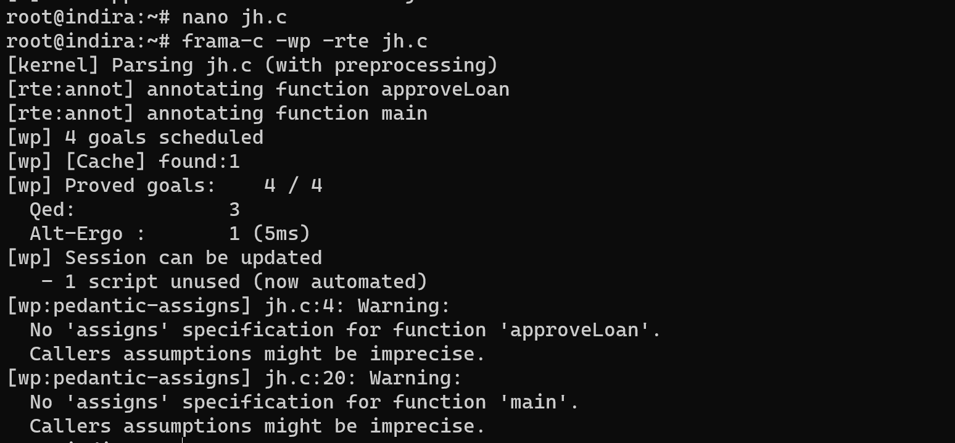

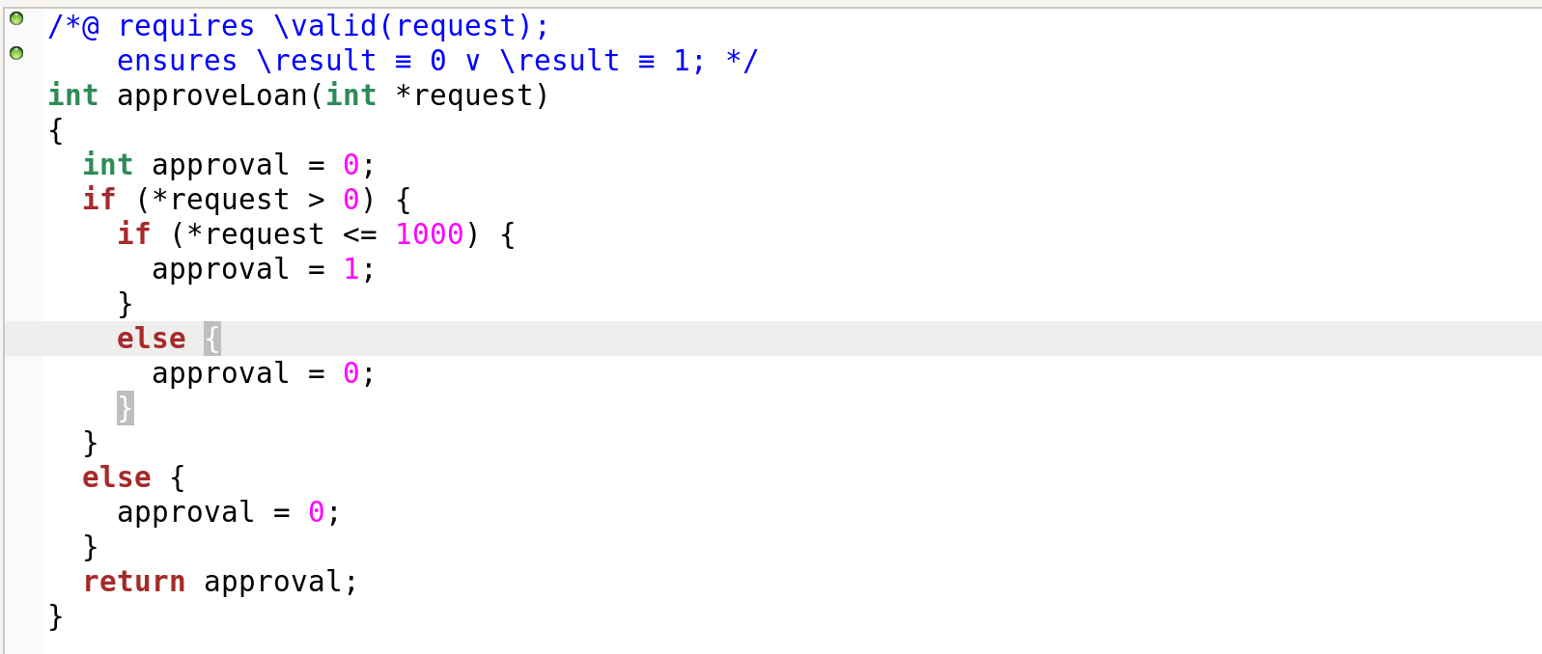

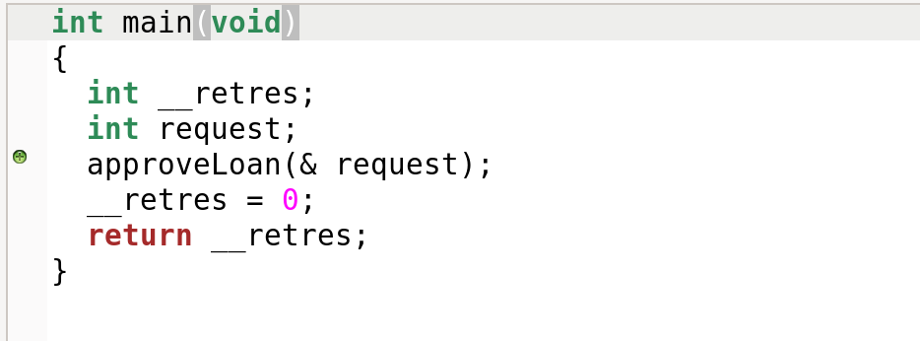

ALT-ERGO CODE

goal c:

forall request :int.

request>=1000->

(request=500

or(not(request=500) and request=0))



**Loops**

C code

#include <stdio.h>

void repayLoan(int *loanAmount) {

int repayments = 0;

while (repayments < *loanAmount) {

repayments += 100;

}

*loanAmount = 0;

}

int main() {

int loanAmount = 1000;

repayLoan(&loanAmount);

return 0;

}

Frama-c code

#include <stdio.h>

/*@

requires \valid(loanAmount);

requires *loanAmount > 0;

assigns *loanAmount;

ensures *loanAmount == 0;

*/

void repayLoan(int *loanAmount) {

int repayments = 0;

/*@

loop invariant 0 <= repayments <= *loanAmount;

loop assigns repayments, *loanAmount;

loop variant *loanAmount - repayments;

*/

while (repayments < *loanAmount) {

//@ assert 0 <= repayments <= *loanAmount; // Additional assertion to help the prover

repayments += 100;

}

//@ assert repayments == *loanAmount;

*loanAmount = 0;

}

int main() {

int loanAmount = 1000;

repayLoan(&loanAmount);

return 0;

}

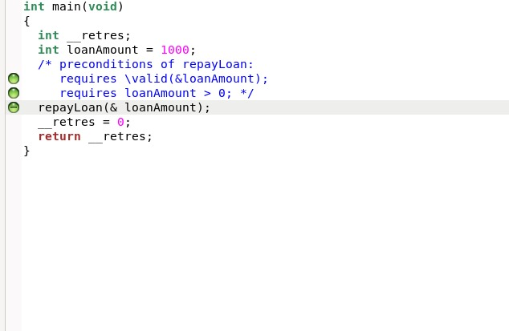

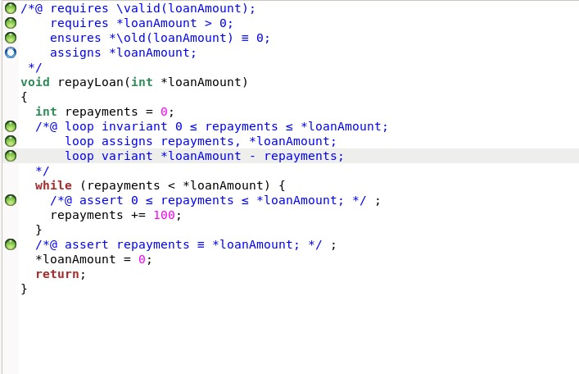

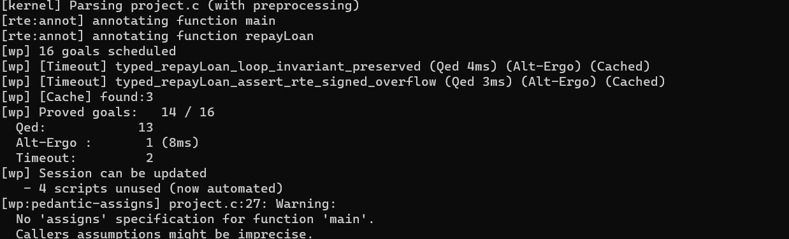

User defined

Frama-c code

#include <stdio.h>

typedef struct {

float loanAmount;

float interestRate;

int durationMonths;

} LoanRequest;

/*@

requires \valid(request);

assigns *request;

ensures request->loanAmount >= 0.0;

ensures request->interestRate >= 0.0;

ensures request->durationMonths >= 0;

ensures \separated(request, &request->loanAmount, &request->interestRate, &request->durationMonths);

*/

void requestLoan(LoanRequest *request) {

scanf("%f", &request->loanAmount);

scanf("%f", &request->interestRate);

scanf("%d", &request->durationMonths);

}

/*@

requires loanAmount >= 0.0;

requires interestRate >= 0.0;

requires durationMonths >= 0;

assigns \nothing;

ensures \result >= 0.0;

*/

float calculateInterest(float loanAmount, float interestRate, int durationMonths) {

float interest = loanAmount * (interestRate / 100.0) * (durationMonths / 12.0);

return interest;

}

/*@

assigns \nothing;

*/

int main() {

LoanRequest request;

requestLoan(&request);

float interest = calculateInterest(request.loanAmount, request.interestRate, request.durationMonths);

printf("Calculated Interest: %.2f\n", interest);

return 0;

}

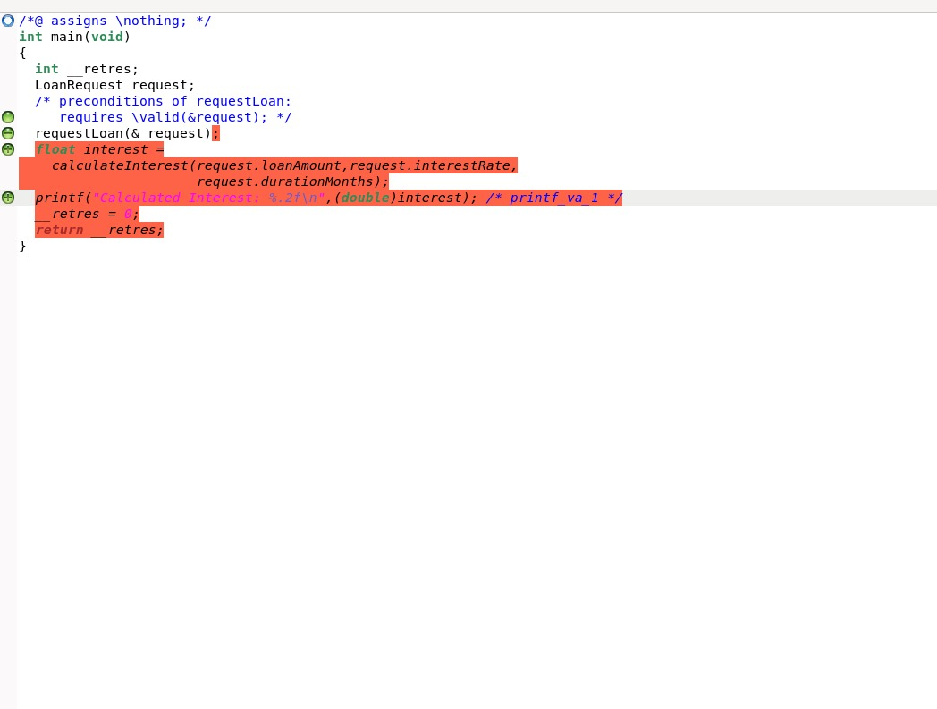

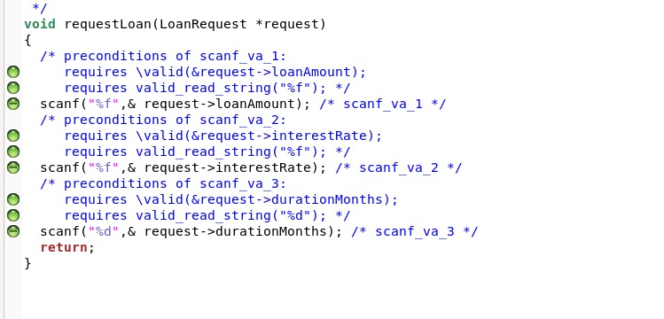



(cb.en.u4cse22431 )

**Assert condition**

Validation of Interest Rate: Assert that the interest rate offered by the lender is greater than or equal to zero. Assert that the interest rate offered by the lender is within an acceptable range

C code:

#include <stdio.h>

#include <assert.h>

int isInterestRateNonNegative(float interestRate) {

return interestRate >= 0;

}

int isInterestRateWithinRange(float interestRate, float minRate, float maxRate) {

return interestRate >= minRate && interestRate <= maxRate;

}

int main() {

float offeredInterestRate = 2.5;

float minAcceptableRate = 0

float maxAcceptableRate = 5;

assert(isInterestRateNonNegative(offeredInterestRate));

assert(isInterestRateWithinRange(offeredInterestRate, minAcceptableRate, maxAcceptableRate));

printf("Interest rate validation passed.\n");

return 0;

}

Frama c code

#include <stdio.h>

/*@

requires \forall float x; x >= 0;

assigns \nothing;

ensures \result == interestRate;

*/

float assertInterestRateNonNegative(float interestRate) {

return interestRate;

}

/*@

requires \forall float x; x >= 0 && x <= 10;

assigns \nothing;

ensures \result == interestRate; // Returns interestRate within the range [0, 10]

*/

float assertInterestRateWithinRange(float interestRate) {

return interestRate;

}

/*@

assigns \nothing;

*/

int main() {

float interestRate = 3.5;

if (interestRate < 0) {

// Behavior: Prints if interestRate is negative

printf("Interest rate cannot be negative.\n");

} else {

// Behavior: Calls function to assert non-negativity of interestRate

interestRate = assertInterestRateNonNegative(interestRate);

if (interestRate > 10) {

// Behavior: Prints message if interestRate is greater than 10

printf("Interest rate should be within the range of 0 to 10.\n");

} else {

// Behavior: Calls function to assert interestRate within the acceptable range

interestRate = assertInterestRateWithinRange(interestRate);

}

}

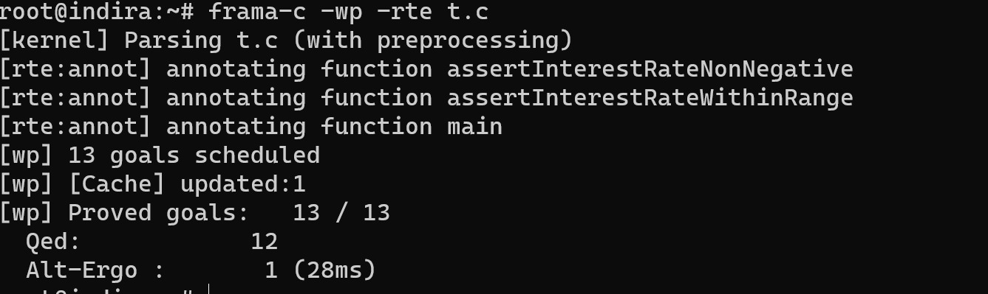

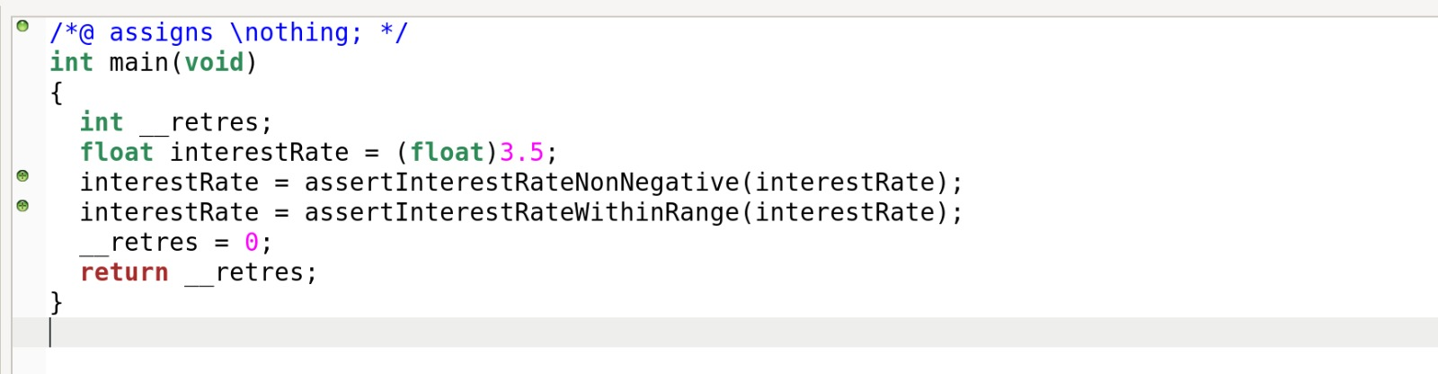

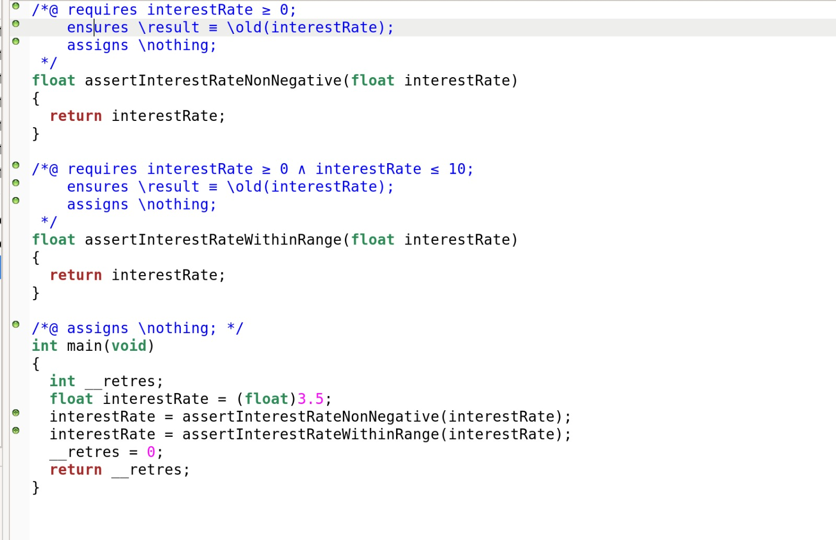

**User defined function :**

C code for loan request()

#include <stdio.h>

typedef struct {

float loanAmount;

float interestRate;

int durationMonths;

char collateral[50];

} LoanRequest;

void requestLoan() {

LoanRequest request;

// Input loan details

printf("Enter loan amount: ");

scanf("%f", &request.loanAmount);

printf("Enter interest rate: ");

scanf("%f", &request.interestRate);

printf("Enter loan duration in months: ");

scanf("%d", &request.durationMonths);

printf("Enter collateral (if applicable): ");

scanf("%49s", request.collateral);

printf("\nLoan request details:\n");

printf("Loan Amount: %.2f\n", request.loanAmount);

printf("Interest Rate: %.2f%%\n", request.interestRate);

printf("Duration (Months): %d\n", request.durationMonths);

printf("Collateral: %s\n", request.collateral);

}

int main() {

requestLoan();

return 0;

}

# Frama c

#include <stdio.h>

typedef struct {

float loanAmount;

float interestRate;

int durationMonths;

char collateral[50];

} LoanRequest;

/*@

requires \valid(request);

assigns *request;

ensures request->loanAmount >= 0.0;

ensures request->interestRate >= 0.0;

ensures request->durationMonths >= 0;

ensures request->collateral[0] != '\0';

*/

void requestLoan(LoanRequest *request) {

scanf("%f", &request->loanAmount);

scanf("%f", &request->interestRate);

scanf("%d", &request->durationMonths);

scanf("%49s", request->collateral);

}

/*@

ensures \result == 0;

*/

int main() {

LoanRequest request;

requestLoan(&request);

return 0;

}

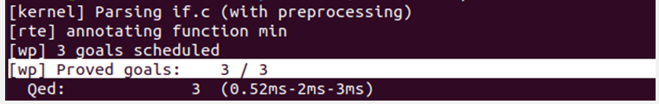

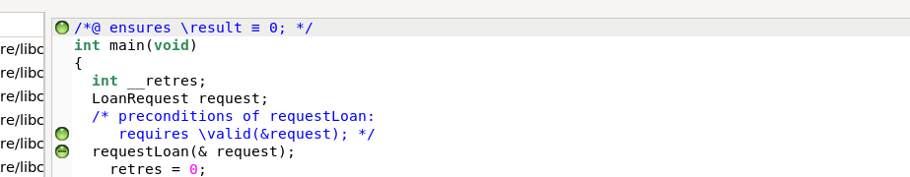

**POINTERS**

**Frama C**

#include <limits.h>

/*@

requires \valid(pre_amount) && \valid(c_amount);

requires INT_MAX - *pre_amount >= *c_amount && *pre_amount >= 0 && *c_amount >= 0;

assigns *pre_amount;

ensures *pre_amount == \old(*pre_amount)+ *c_amount;

ensures *c_amount == \old(*c_amount);

*/

int increment(int* pre_amount, int* c_amount){

*pre_amount += *c_amount;

return *pre_amount;

}

int main(){

int pre_amount = 50000;

int c_amount = 25000;

int total;

total = increment(&pre_amount,&c_amount);

//@ assert total == pre_amount +c_amount;

//@ assert total <=100000;

}

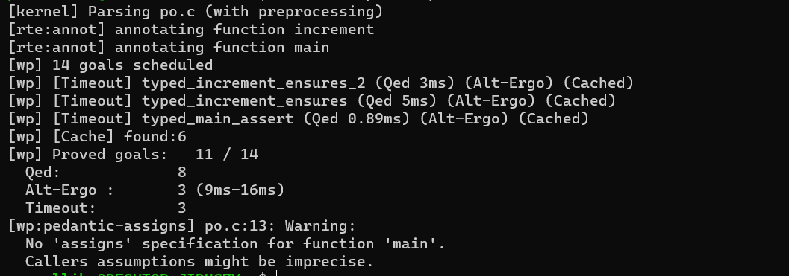

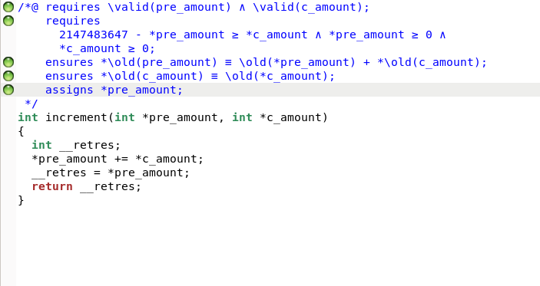

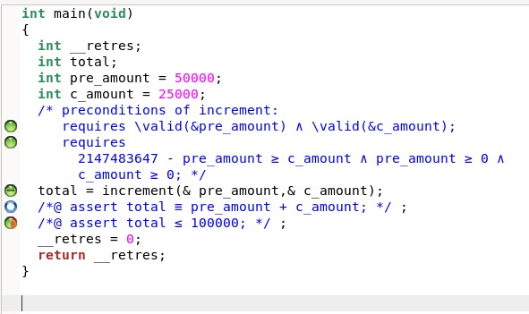

**Mutable Arrays:**

**C code:**

void lendMoney(double accounts[], int userId, double amount) {

if (userId >= 0 && userId < 5 && amount > 0 && accounts[userId] >= amount) {

accounts[userId] -= amount;

} else {

}

}

int main() {

double userAccounts[] = {10000.0, 5000.0, 8000.0, 12000.0, 6000.0};

lendMoney(userAccounts, 2, 1000.0);

lendMoney(userAccounts, 4, 1500.0);

lendMoney(userAccounts, 6, 500.0);

lendMoney(userAccounts, 1, -200.0);

return 0;

}

**Frama -c code:**

/*@

requires \valid(accounts + (0..4));

ensures \forall integer k; 0 <= k < 5 ==> accounts[k] >= 0;

assigns accounts[0..4];

*/

void lendMoney(double accounts[], int userId, double amount) {

if (userId >= 0 && userId < 5 && amount > 0 && accounts[userId] >= amount) {

accounts[userId] -= amount;

//@ assert accounts[userId] >= 0;

} else {

//@ assert \false;

}

}

int main() {

double userAccounts[] = {10000.0, 5000.0, 8000.0, 12000.0, 6000.0};

lendMoney(userAccounts, 2, 1000.0);

lendMoney(userAccounts, 4, 1500.0);

lendMoney(userAccounts, 6, 500.0);

lendMoney(userAccounts, 1, -200.0);

//@ assert \valid(userAccounts + (0..4));

//@ assert 0 <= 2 < 5 && 1000.0 > 0;

//@ assert 0 <= 4 < 5 && 1500.0 > 0;

return 0;

}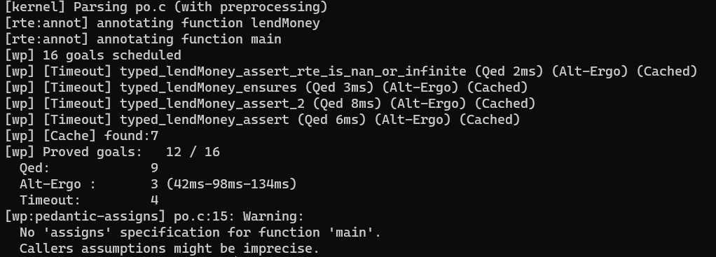

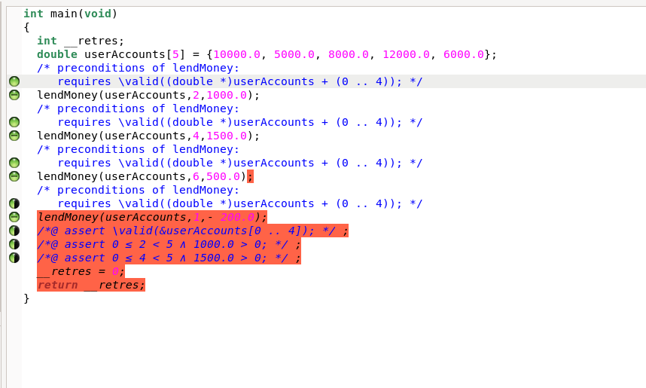

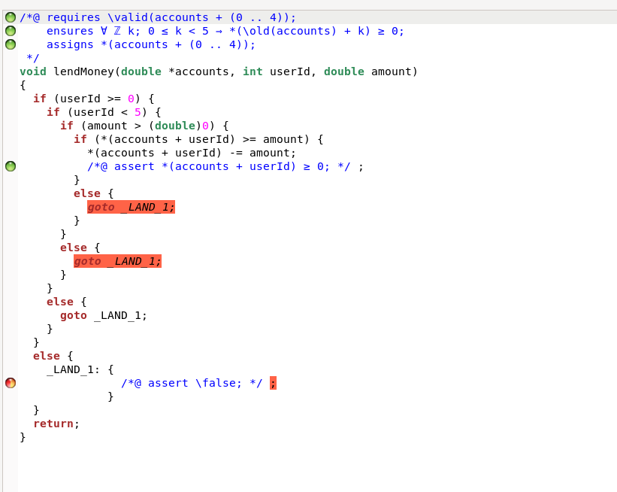

**Alt Ergo:**

**Code:**

goal c:

forall amount :int.

amount=4000->

(amount>=3000

or(not(amount>=3000) and amount<3000))



**Sorting:**

**The provided code implements the Bubble Sort algorithm to sort an array of loan amounts (loanAmounts)**

**Frama C code:**

#include <stdio.h>

/*@

requires n >= 0 && \valid(amounts + (0..n-1));

ensures \forall integer k; 0 <= k < n-1 ==> amounts[k] <= amounts[k+1];

assigns amounts[0..n-1];

*/

void bubbleSort(int n, int amounts[]) {

/*@

loop invariant 0 <= i <= n;

loop invariant \forall integer k; 0 <= k < i ==> \forall integer l; 0 <= l < n - i - 1 ==> amounts[l] <= amounts[l+1];

loop assigns i, amounts[0..n-1];

loop variant n - i;

*/

for (int i = 0; i < n - 1; i++) {

/*@

loop invariant 0 <= j <= n - i - 1;

loop invariant \forall integer k; 0 <= k < n - i - 1 ==> amounts[k] <= amounts[k+1];

loop assigns j, amounts[0..n-1];

loop variant n - i - j;

*/

for (int j = 0; j < n - i - 1; j++) {

if (amounts[j] > amounts[j + 1]) {

int temp = amounts[j];

amounts[j] = amounts[j + 1];

amounts[j + 1] = temp;

}

}

}

}

int main() {

int numLoans = 5;

int loanAmounts[] = {3000, 1500, 5000, 2000, 1000};

bubbleSort(numLoans, loanAmounts);

/*@

assigns \nothing;

*/

return 0;

}

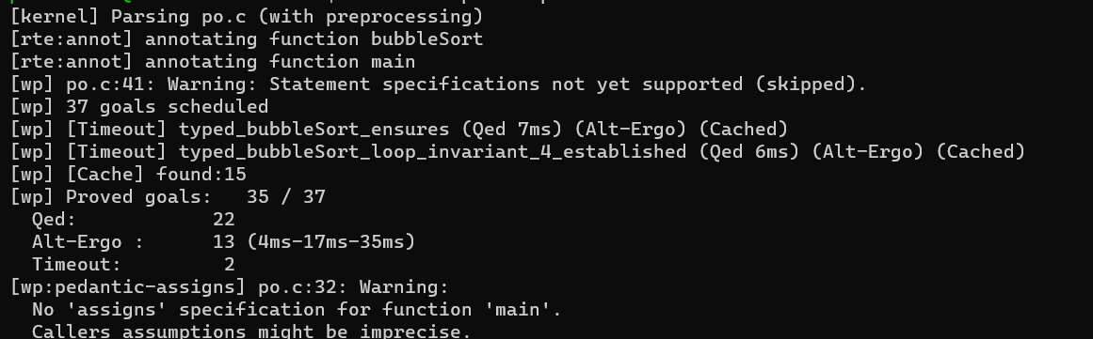

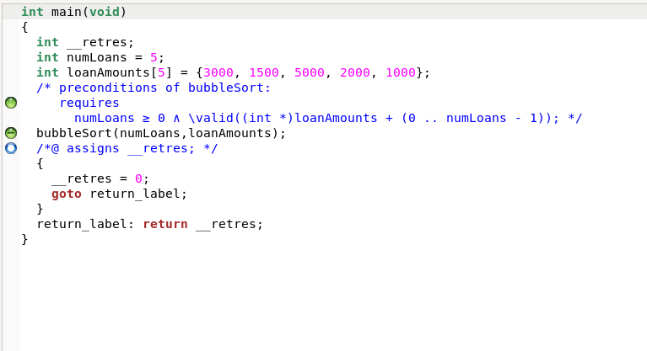

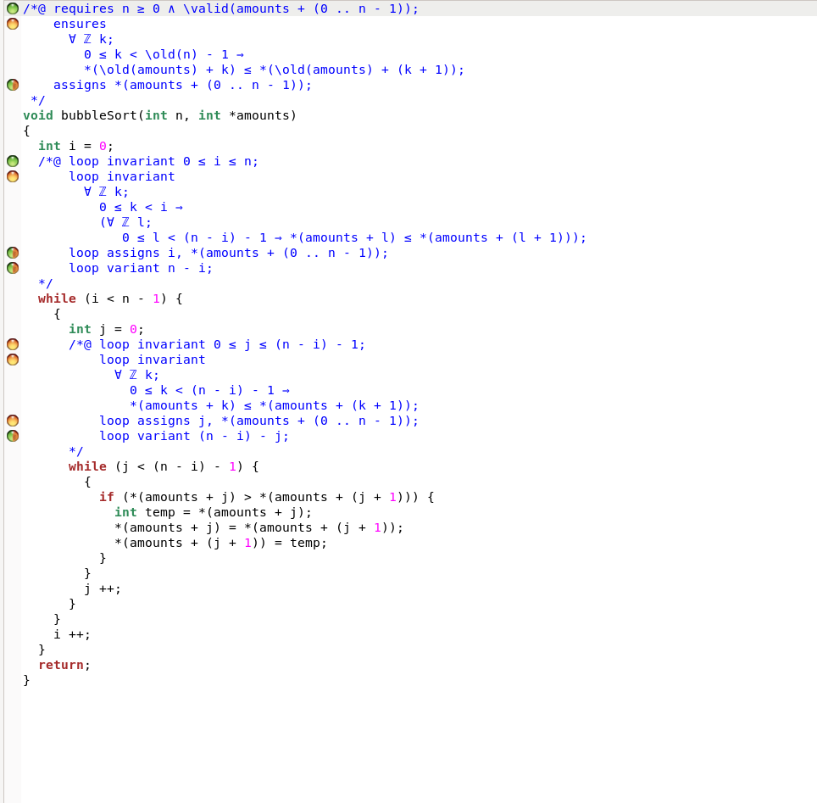

**Searching:**

**The provided code defines a function searchAndCommunicate that searches for a specific data item (searchData) in two sets of local data (localData1 and localData2). The function returns 1 if the data is found either locally in the first set or remotely in the second set, and 0 otherwise.**

**C code:**

#include <stdio.h>

#include <stdlib.h>

int searchOnNode(int nodeID, int searchData, int* localData, int dataSize) {

for (int i = 0; i < dataSize; ++i) {

if (localData[i] == searchData) {

return 1;

}

}

return 0;

}

int communicateBetweenNodes(int senderID, int receiverID, int searchData, int* localData1, int dataSize1, int* localData2, int dataSize2) {

int found = searchOnNode(receiverID, searchData, localData2, dataSize2);

return found;

}

int main() {

int searchData = 3;

for (int nodeID = 0; nodeID < 3; ++nodeID) {

int localData[] = {1, 2, 3, 4, 5};

int dataSize = sizeof(localData) / sizeof(localData[0]);

int foundLocally = searchOnNode(nodeID, searchData, localData, dataSize);

if (!foundLocally) {

for (int otherNodeID = 0; otherNodeID < 3; ++otherNodeID) {

if (otherNodeID != nodeID) {

int foundRemotely = communicateBetweenNodes(nodeID, otherNodeID, searchData, localData, dataSize, localData, dataSize);

if (foundRemotely) {

break;

}

}

}

}

}

return 0;

}

**Frama-c code:**

#include <stdio.h>

int searchAndCommunicate(int searchData, int* localData1, int dataSize1, int* localData2, int dataSize2);

/*@

requires \valid(localData1 + (0 .. dataSize1-1));

requires \valid(localData2 + (0 .. dataSize2-1));

ensures \result == 1 ==> (\exists integer i; 0 <= i < dataSize2 && localData2[i] == searchData);

ensures \result == 0 ==> (\forall integer i; 0 <= i < dataSize2 ==> localData2[i] != searchData);

assigns \nothing;

*/

int searchAndCommunicate(int searchData, int* localData1, int dataSize1, int* localData2, int dataSize2) {

// Search locally in the first set of data

for (int i = 0; i < dataSize1; ++i) {

if (localData1[i] == searchData) {

return 1; // Found locally

}

}

for (int i = 0; i < dataSize2; ++i) {

if (localData2[i] == searchData) {

return 1;

}

}

return 0;

}

int main() {

int searchData = 3;

int localData1[] = {1, 2, 3, 4, 5};

int dataSize1 = sizeof(localData1) / sizeof(localData1[0]);

int localData2[] = {6, 7, 8, 9, 10};

int dataSize2 = sizeof(localData2) / sizeof(localData2[0]);

int result = searchAndCommunicate(searchData, localData1, dataSize1, localData2, dataSize2);

return 0;

}

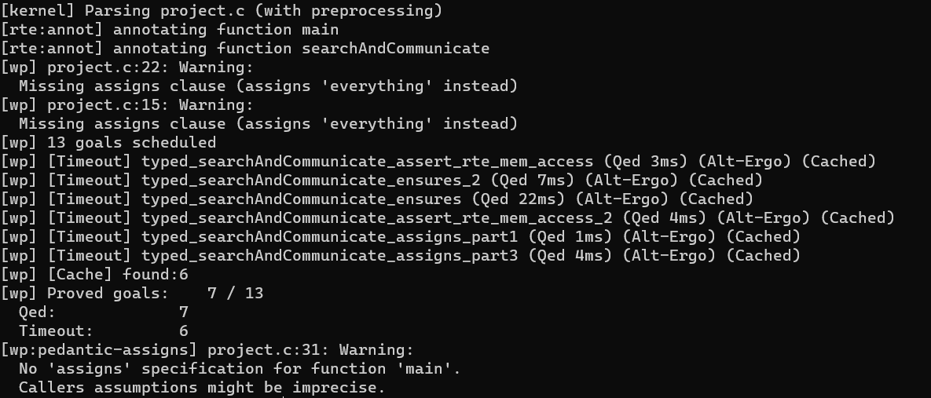

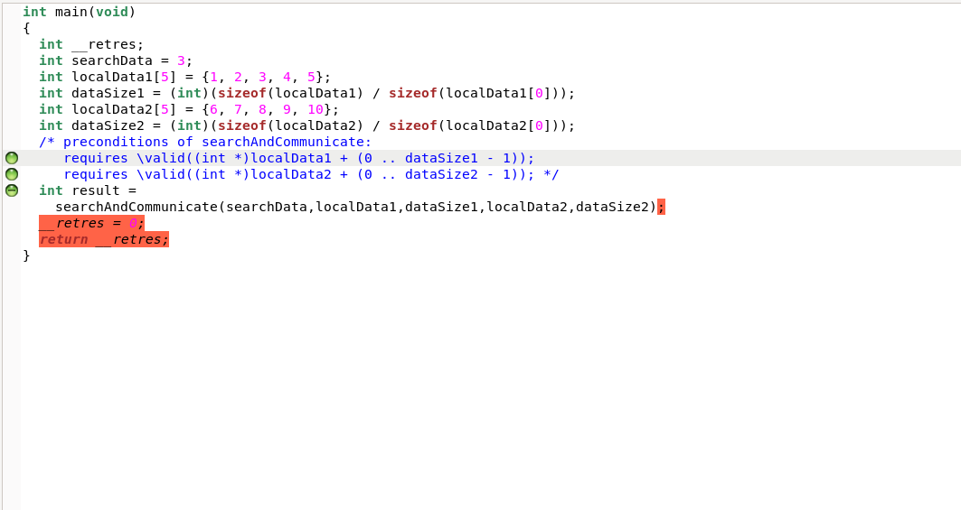

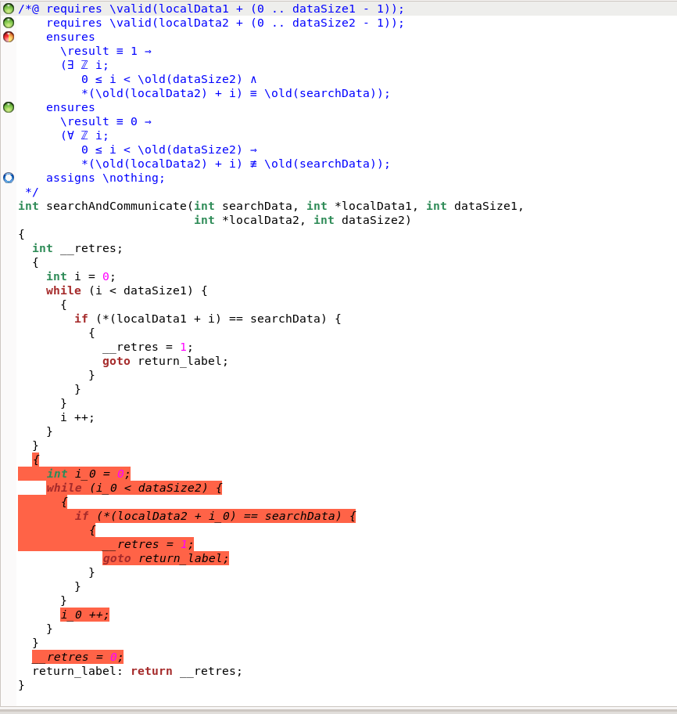

**Immutable Arrays:**

**The provided code defines a function findMaxBalance that aims to find the maximum balance among a set of participant accounts.**

**C-CODE:**

double findMaxBalance(double accountBalances[], int numParticipants) {

double maxBalance = accountBalances[0];

for (int participants = 1; participants < numParticipants; participants++) {

if (accountBalances[participants] > maxBalance) {

maxBalance = accountBalances[participants];

}

}

return maxBalance;

}

int main() {

int numParticipants = 5;

double accountBalances[] = {1000.0, 2000.0, 1500.0, 3000.0, 2500.0};

double maxBalance = findMaxBalance(accountBalances, numParticipants);

return 0;

}

**Frama-c code**

/*@

requires numParticipants > 0;

requires \valid_read(accountBalances + (0 .. numParticipants - 1));

ensures \forall integer participant; 0 <= participant < numParticipants ==> \result >= accountBalances[participant];

*/

double findMaxBalance(double accountBalances[], int numParticipants) {

double maxBalance = accountBalances[0];

/*@

loop invariant \forall integer participant; 0 <= participant < participants ==> maxBalance >= accountBalances[participant];

loop invariant 1 <= participants <= numParticipants;

loop assigns participants, maxBalance;

loop variant numParticipants - participants;

*/

for (int participants = 1; participants < numParticipants; participants++) {

if (accountBalances[participants] > maxBalance) {

maxBalance = accountBalances[participants];

}

}

return maxBalance;

}

int main() {

int numParticipants = 5;

double accountBalances[] = {1000.0, 2000.0, 1500.0, 3000.0, 2500.0};

double maxBalance = findMaxBalance(accountBalances, numParticipants);

//@ assert maxBalance >= accountBalances[0];

return 0;

}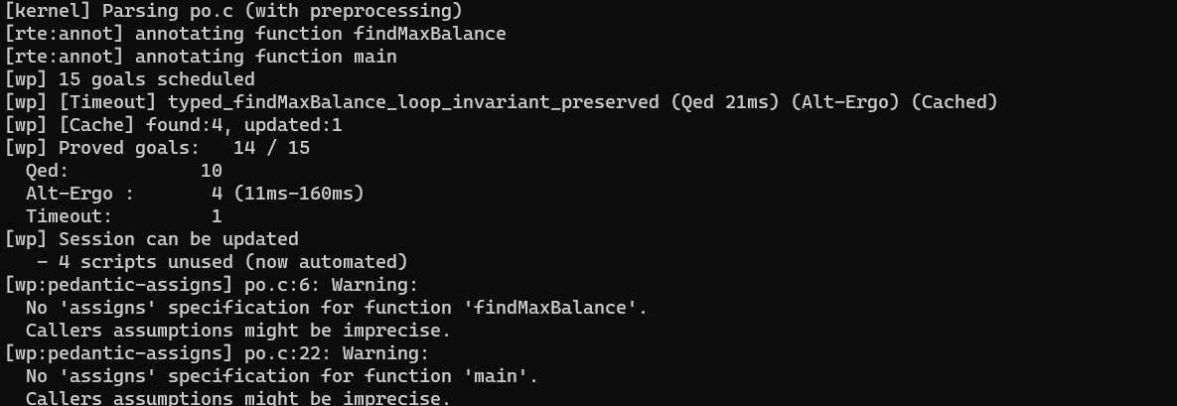

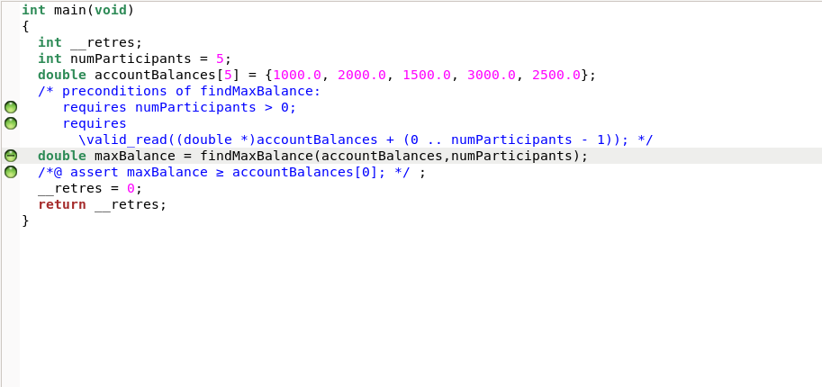

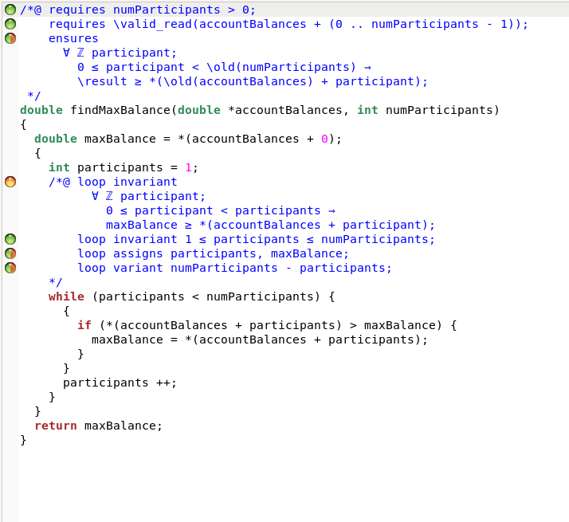

**Alt ergo:**

goal c:

forall x,y,z :int.

(x=3 and y=2 and z=1)->

((x>y) and (x>z) and (x>0)

or(not((x>y) and (x>z)) and (y>x) and (y>z) and (y>0))

or(not((x>y) and (x>z)) or ((y>x) and (y>z)) and (z>0)))

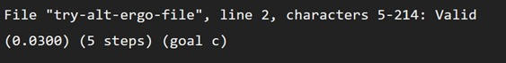

**Linear temporal logic**

Always (Globally) Operator (G):

Description: Ensures that a property holds at every moment in time.

Example: G(loan_repaid→contract_closed)

Eventually Operator (F):

Description: Asserts that a property will eventually become true in the future.

Example: F(totalRepayments >= loanAmount)

Until Operator (U):

Description: Specifies that one property will hold until another property becomes true.

Example: loan_repaidUcontract_closed

Next Operator (X):

Description: Indicates that a property will hold in the next time step.

Example: X(interest_payment_due)

**Aximotic**

#include <stdio.h>

/*@

axiomatic UserAxiomatics {

logic integer userCount;

axiom initial_user_count: userCount == 0;

predicate ValidUserCount(integer count) = 0 <= count <= 100;

}

*/

/*@

axiomatic LoanAxiomatics {

logic integer loanCount;

axiom initial_loan_count: loanCount == 0;

predicate ValidLoanCount(integer count) = 0 <= count <= 100;

}

*/

int userCount;

int loanCount;

/*@ requires \valid(users + (0..99)) && \valid(loans + (0..99));

assigns userCount, loanCount, users[0..99], loans[0..99];

ensures ValidUserCount(userCount) && ValidLoanCount(loanCount);

*/

void initializeSystem(int users[100], int loans[100]) {

for (int i = 0; i < 100; ++i) {

users[i] = 0;

loans[i] = 0;

}

userCount = 0;

loanCount = 0;

}

/*@ requires ValidUserCount(userCount) && userCount < 100;

assigns userCount, users[0..99];

ensures ValidUserCount(userCount);

*/

void registerUser(int users[100]) {

users[userCount] = userCount + 1;

userCount++;

}

/*@ requires ValidLoanCount(loanCount) && loanCount < 100;

assigns loanCount, loans[0..99];

ensures ValidLoanCount(loanCount);

*/

void requestLoan(int loans[100]) {

loans[loanCount] = loanCount + 1;

loanCount++;

}

int main() {

int users[100];

int loans[100];

initializeSystem(users, loans);

registerUser(users);

requestLoan(loans);

return 0;

}

